|  |  |
| --- | --- |
| 618 E. 10 Mile Road Hazel Park, MI 48030 |  |

Project: 6484 buttin Rd, Whitemore Lake Rd, MI 48189,

Request for Range

Building Type: Commercial

|  |  |  |
| --- | --- | --- |
| Date | Services Performed By: | Services Performed For: |
| April 1, 2014 | Parjana Inc.  618 E. 10 Mile Road Hazel Park, MI 48030 | Parjana Distribution, LLC.  1274 Library Street, Suite 600 Detroit, MI 48226 |

**Statement of Problem:**

The plan for this site is to setup a test site at holes 6 and 12 at the Rolling Meadows Golf Course.

**Quotation:**

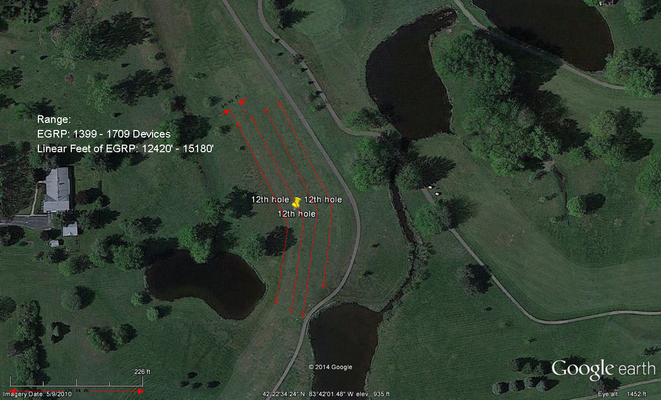

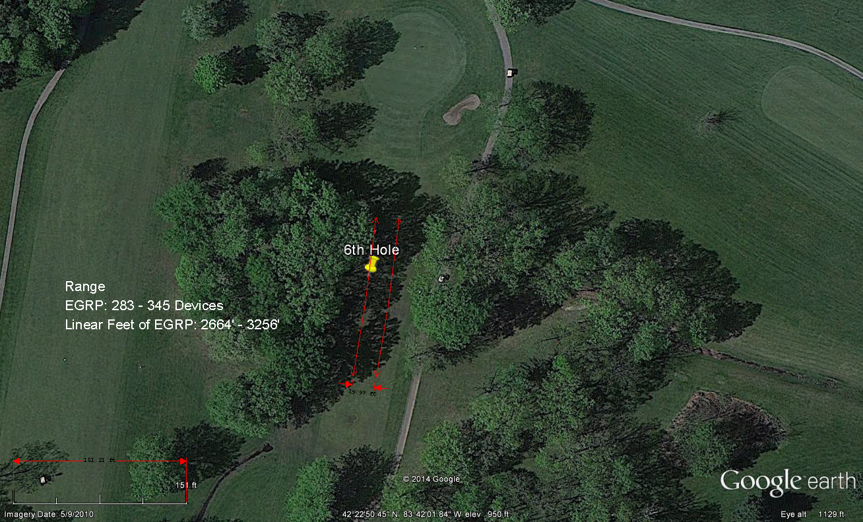

**Engineering Notes:**

None to report the plan is resolve the standing water issues at the selected test areas.